Towards a Common Braille Math Code for Flemish Students
Jan Engelen
Katholieke Universiteit Leuven
Kasteelpark Arenberg 10 box 2442
3001 Leuven
Belgium

Bart Simons
Blindenzorg Licht en Liefde
Kunstlaan 24 box 21
1000 Brussel
Belgium
Abstract
In April 2010 a working group was set up under auspices of the Vlaamse Onderwijsraad (VLOR), the advisory board to the Flemish Minister of Education, to create a new math braille code. However it became clear from the discussions that a new code alone would not solve the problems of teaching math to visually impaired students in the mainstream educational system. In this contribution we will explain how only a combination of specialised software and a new code can be successful as a long term solution.
- History
Since the mid 70’s Flanders has agreed on a code to represent mathematical formulae in braille. This code has been in use for over thirty years in primary, secondary and higher education. During this time there was no real discussion about the code.

In this text we will refer to this code as the Notaert code. It was developed by Mr. van der Mey and Mr. Notaert, who based their ideas strongly on the German Marburg code. The Notaert code is:

- Logical: The code follows very systematic rules. Especially in schools for the blind the code can thus be taught relatively easily.
- Unambiguous: The braille code follows strictly the written math and is not an interpretation. E.g. the code does not explain that something is set to the power 3. Instead it just indicates that a 3 is written in superscript. Just like the sighted student the blind reader has to understand what this means.
- Compact: By using special characters rather than abbreviations the code is kept as dense as possible.
- Mainstream Schools
Since 1990 blind students integrate in mainstream schools whenever possible. This would not have been possible without the development of assistive technologies. In the beginning the student had a note taker. Since a sighted teacher does not know braille, let alone math in braille, the Sensotec Euroscope note taker did the conversion from braille to printed text on a screen or printed on paper. Thanks to the unambiguity of the Notaert code, developers could adapt the software so that not only text but also the math could be processed.

A note taker was only a solution for written communication from the student to the teacher. The other way round was not possible because a note taker only accepts braille input. This was taken care of by transcription centres and specialised ambulatory staff. They collect the texts to be brailled and bring them back one week later.

This system worked fine for several generations of students but the ICT developments did not stop and new working methods appeared:

- Blind students started to use a laptop rather than a note taker.
- The teacher can now pass on digital documents directly to the student. Many teachers prefer this because there is no delay and it facilitates two-way written communication. For texts this works fine but for math a serious problem remains because the teachers don't know the Notaert code.

People then started to use several kinds of pseudo-code to describe the math but such a diversity is absolutely not favourable for students, schools, transcription centres, software developers etc.
Competing codes in a small region such as Flanders is problematic for everyone, that is why Flanders wanted a new, unified code for transcribing math in braille.
- Methodology
In April 2010 a working group was set up under auspices of the Vlaamse Onderwijsraad (VLOR), the advisory board to the Flemish Minister of Education. The group consists of representatives from the transcription centres, the different schools for the blind and their teams that assist students in mainstream schools, the braille users and software developers. Chair is Prof. Jan Engelen who is knowledgeable simultaneously in math, braille and accessibility. We are privileged to have also Mr. Notaert at the table, former math teacher in the Woluwe school for the blind and co-author of the above mentioned math braille code that served so many students in the past.

During one year the working group had monthly meetings. As the problem of pseudo math codes is a general problem, at least in Europe, we have started by exploring the existing code schemes, in Belgium but also in the Netherlands, France and Germany as well as other math coding schemes that were not developed in the first place for braille, such as MathML and LaTeX/LiTeX.

The working group was also following up the activities of the Comenius project “Touching Maths”. Furthermore we had demonstrations of a couple of software tools for math processing.

During our discussions we identified the following issues with the Notaert code:

- In a mainstream school guidance is missing to correctly teach the code. Although it follows strict rules that are easy to learn as an adult or with the guidance of a teacher in the school for the blind it is difficult to familiarise young children in a mainstream school with this code.
- The blind student needs to be able to write math in braille. This can only be done on a note taker and not on a laptop. The student does not want to carry both a note taker and a laptop to school because for all other courses the laptop is enough.
- The sighted teacher in a mainstream school can't produce digital math in braille. But math teachers want, just like their colleagues, to avoid that ambulatory teachers must transcribe their documents into braille which takes time.
- The code is fine for blind students but is quite different from the written math. Partially sighted students or students who become blind on a later age have problems to adapt to this abstract code system.
- The code is not in line with math notation in Excel, on calculators or math processing software such as Matlab or Mathematica.

Summary: The main problem of a braille code is that it has to be written in braille. This makes it impossible to use for most people. The blind students who know braille don't have the device anymore to write braille since they prefer to carry only their laptop.

The VLOR working group has sought a solution in two different directions:

- A more text based code that can be typed on any keyboard and that is readable by blind and sighted people alike,
- More convenient software tools to convert math into braille and back.
- A New Code
Several institutions, in Belgium as well as abroad, started independently of each other to develop a more descriptive/verbose math code. LaTeX and MathML were found to be too complicated for use in primary and lower secondary education. The Dedicon code used in the Netherlands was found to be ambiguous due to the many brackets and its verbosity.

The working group concluded that none of these codes under development reached the same standards as the Notaert code, such as unambiguity, completeness and brevity so the majority of the group members was definitely not ready to give up the Notaert code. The main conclusion at that point in time was that both a new code and new software would be required to escape from this bottleneck.
- Software
Two software developers around the table have addressed the above issue.
First by bringing the note taker's math capacity to the laptop. A braille keyboard is simulated on six keyboard keys. Software would translate the math into printed math on the screen or on paper. This works fine but some laptop keyboards don't allow input with multiple keys pressed simultaneously (this is a hardware limitation). A solution can be to use a separate braille keyboard but this needs to be carried separately. It does not solve the other scenario where a teacher wants to produce braille.

The other solution starts from the idea that if we want sighted math teachers to communicate digitally with their blind student(s), we should start from what the teacher knows already: the formula editor in Microsoft Word. The Belgian assistive technology company Sensotec developed a plug-in for Word that allows immediate conversion from math formulae into Notaert code and into a format that is easier to read (Sensomath). This real-time translation from each of the three inputs to the two other outputs makes many scenarios possible:

- A teacher can provide the blind student with a digital copy of a test that (s)he made in Word using the regular math editor. So (s)he does not need to learn something new.
- The student can receive the document and read it on the braille display. (S)he can read the document either in the Notaert code or in the special format.
- A blind student who is familiar with the Notaert code and has a braille keyboard hooked up to his or her laptop can continue to input braille as before. The software makes it accessible for sighted people because it uses the default solution for math in Word.
- The teacher can receive a document from the student and make corrections in it using the math editor.
- The student who is not familiar with the Notaert code or who is partially sighted can read and write the special format.

The Flemish working group believes that the Sensomath approach is the revolutionary solution that we needed to solve our dissension between the robust but specific Notaert code and the different codes under development that are easier to read and write but that are not yet thoroughly tested nor proven correct and complete.

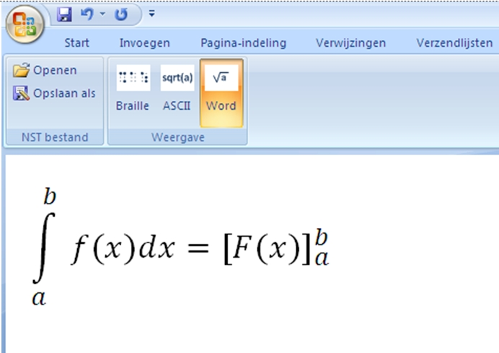 | 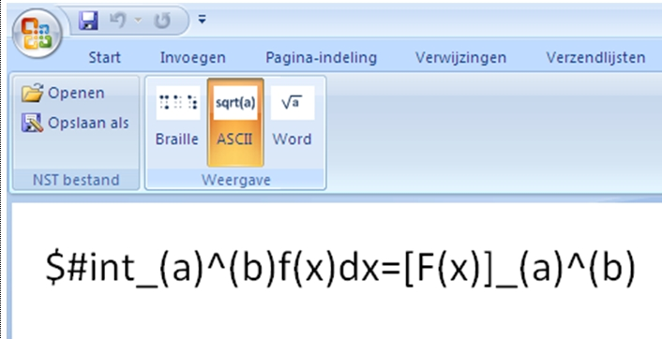
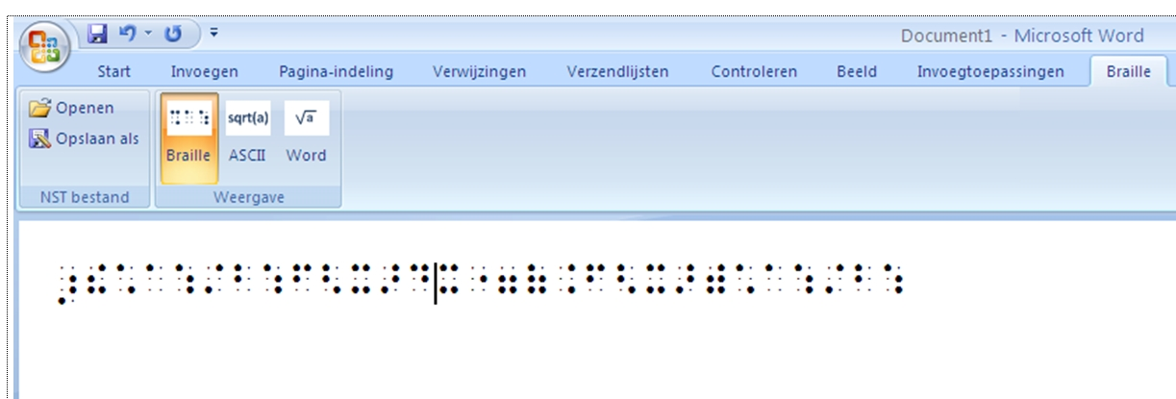
Figure 1: Screen shots of three versions of the same formula in Sensomath (graphical, Ascii, math braille/Notaert). Warning: the Ascii coding (top right) is still under development.
- The Way Forward
From the description above it is clear that the Sensomath development was welcomed by the working group as the real solution to the problems of teaching math to visually impaired students.

However two major problems still need to be solved in the near future:
The descriptive textual code (named Ascii in the Sensomath application) still has to be finalised. This requires a very rigorous approach as it is essential that the correct Notaert code and the graphical code have to be created automatically.
The other outstanding problem is a financial one: the Sensotec company needs to be able to turn its Sensomath prototype into a commercial product at an affordable price.

Solving both bottlenecks is the main task for the VLOR working group in the next couple of months. Its members however are confident that solutions will be found. In the spring of 2012 a special one day conference on math braille will be organised.
- Conclusion
Although the Flemish working group was initially mandated to create a new math braille code, it has become clear that the creation of such a, more text based, code would not constitute the long term solution.
Only a combination of a new code and adequate software can provide a real solution. These processes fortunately are now under way in Flanders.

http://www.icevi-europe.org/enletter/issue46.html#a5

